**Practical No 5**

**Aim:** Database implementation using pointer to structure.

**Program:**

|  |
| --- |
| #include <stdio.h>  #include <conio.h>  #include <stdlib.h>  #include <string.h>  #define MAX 10  struct CovidPatients  {  int patientno;  char name[MAX];  int age;  int level;  }CP[MAX];  struct CovidPatients *ptr;  int main()  {  printf("Program by Manthan Jadhav\n") ;  printf("Roll No.: 34\n");  printf("Reg No: 20010381\n");  int n, i, key, ch;  ptr=(struct CovidPatients*)&CP;  char res;    do  {  printf("1. Create\n2.Display\n3.Search\n4.Display Particular record\n");  printf("Enter your choice :");  scanf("%d", &ch);  switch (ch)  {  case 1: //Creating  printf("\nEnter the no. of covid Patients : ");  scanf("%d", &n);  for (i = 0; i < n; i++)  {  printf("\n Enter the Patient Number of %d :\t", i + 1);  scanf("%d", &ptr->patientno);  printf("\n Enter the Patient name of %d :\t", i + 1);  scanf("%s", ptr->name);  printf("\n Enter the Patient age %d :\t", i + 1);  scanf("%d", &ptr->age);  printf("\n Enter the Patient Oxygen level of %d :\t", i + 1);  scanf("%d", &ptr->level);  ptr++;  }  ptr=(struct CovidPatients*)&CP;  break;  case 2: //display  printf("\nSr.no\tP_No.\tName\t\tAge\tO2Level\n");  for (i = 0; i < n; i++)  {    printf("%d\t%d\t%s\t\t%d\t%d\n",i+1, ptr->patientno,ptr->name,ptr->age,ptr->level);  ptr++;  }  ptr=(struct CovidPatients*)&CP;  break;  case 3: //searching  printf("\n Enter the Patient number to search :");  scanf("%d", &key);  for (i = 0; i < n; i++)  {  if (ptr->patientno == key)  {  printf("Match found\n");  printf("\n The patient number is : %d", ptr->patientno);  printf("\n The name of %d patient is : %s", i + 1, ptr->name);  printf("\n The age of %d patient is : %d", i + 1, ptr->age);  printf("\n The Oxygen level of %d Patient is : %d", i + 1, ptr->level);  break;  }  ptr++;  }  if(i==n)  {  printf("\n\t\tNO MATCH FOUND\n");  }  ptr=(struct CovidPatients*)&CP;  break;  case 4: //display particular record  printf("Display of all patient record having age greater than 75\n");    for (i = 0; i < n; i++)  {  if (ptr->age>=75)  {  printf("\n The patient number is : %d", ptr->patientno);  printf("\n The name of %d patient is : %s", i + 1, ptr->name);  printf("\n The age of %d patient is : %d", i + 1, ptr->age);  printf("\n The Oxygen level of %d Patient is : %d", i + 1, ptr->level);  }  ptr++;  break;    }  if(i==n)  {  printf("NO patient having age greater than 75");  }    break;  default:  exit(0);  }  printf("\nWants to continue then press y :");  scanf("%s", &res);  } while (res == 'y');  return 0;  }  /*Program by Manthan Jadhav  Roll No.: 34  Reg No: 20010381  1. Create  2.Display  3.Search  4.Display Particular record  Enter your choice :1  Enter the no. of covid Patients : 3  Enter the Patient Number of 1 : 101  Enter the Patient name of 1 : Manthan  Enter the Patient age 1 : 76  Enter the Patient Oxygen level of 1 : 92  Enter the Patient Number of 2 : 102  Enter the Patient name of 2 : Saurabh  Enter the Patient age 2 : 56  Enter the Patient Oxygen level of 2 : 95  Enter the Patient Number of 3 : 103  Enter the Patient name of 3 : Lalit  Enter the Patient age 3 : 67  Enter the Patient Oxygen level of 3 : 89  Wants to continue then press y :y  1. Create  2.Display  3.Search  4.Display Particular record  Enter your choice :2  Sr.no P_No. Name Age O2Level  1 101 Manthan 76 92  2 102 Saurabh 56 95  3 103 Lalit 67 89  Wants to continue then press y :y  1. Create  2.Display  3.Search  4.Display Particular record  Enter your choice :3  Enter the Patient number to search :102  Match found  The patient number is : 102  The name of 2 patient is : Saurabh  The age of 2 patient is : 56  The Oxygen level of 2 Patient is : 95  Wants to continue then press y :y  1. Create  2.Display  3.Search  4.Display Particular record  Enter your choice :4  Display of all patient record having age greater than 75  The patient number is : 101  The name of 1 patient is : Manthan  The age of 1 patient is : 76  The Oxygen level of 1 Patient is : 92  Wants to continue then press y :n  /* |

**OUTPUT:**

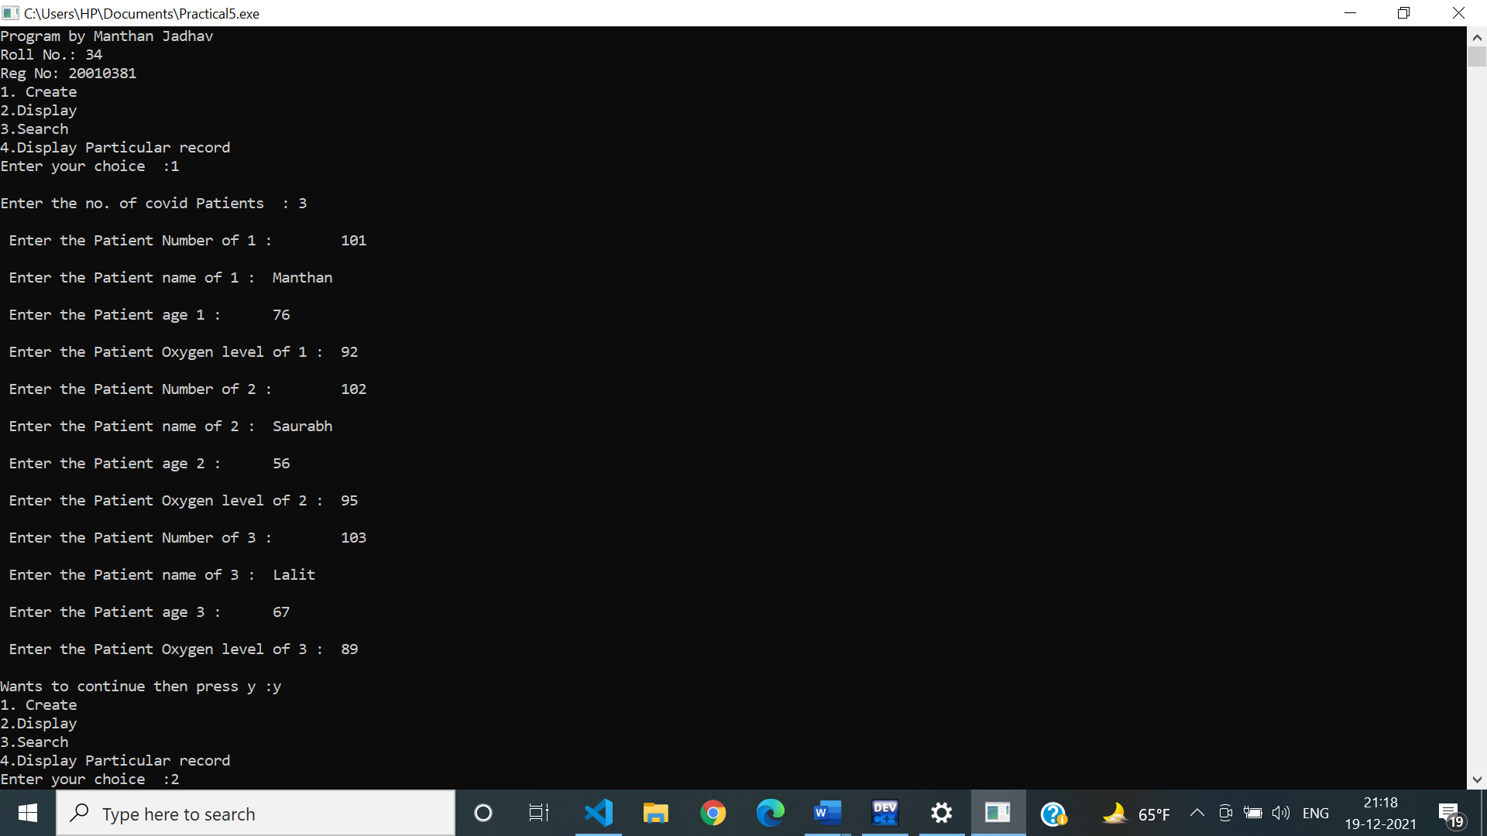

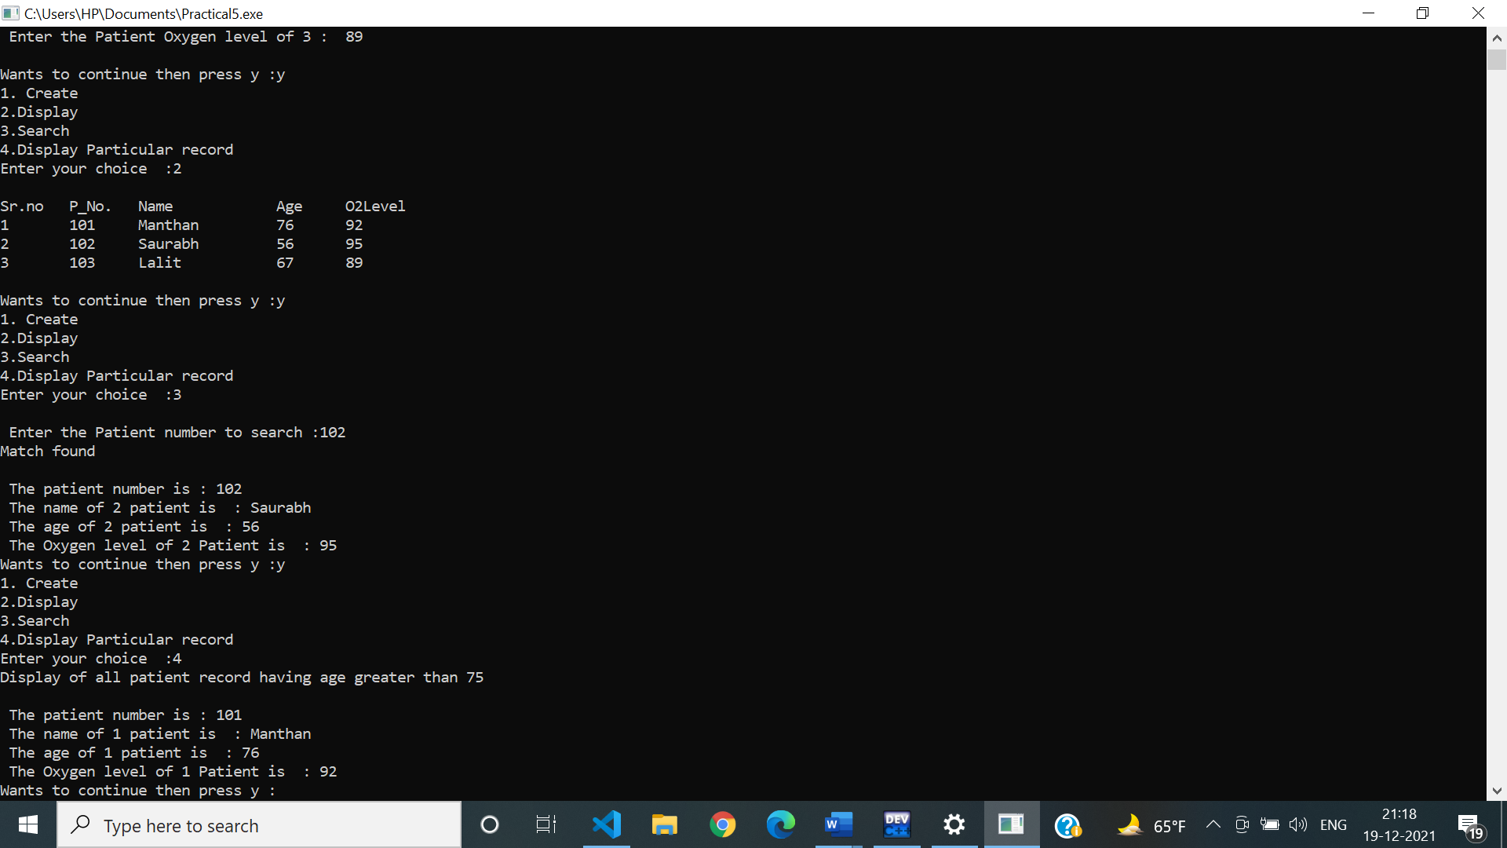

**Practical No: 6**

**Aim:** Program based on linked list.

**Program:**

|  |
| --- |
| /*Practical N0. 6*/  #include<stdio.h>  #include<stdlib.h>  #include<string.h>  #define MAX 100  typedef struct coffee_shop  {  char C_Name[MAX];  char C_Brand[MAX];  int N;  float Bill;  struct coffee_shop *next;  }*CS;  CS getnode()  {  CS new1;  new1=malloc(sizeof(struct coffee_shop));  new1->next=NULL;  }  void Alphabetical_order(CS head)  {  CS p1,p2;  char temp1[20],temp2[20];  int s1,s2;  p1=head;  while(p1!=NULL)  {  p2=p1;  while(p2!=NULL)  {  if(strcmp(p1->C_Name,p2->C_Name)>0)  {  strcpy(temp1,p1->C_Name);  strcpy(p1->C_Name,p2->C_Name);  strcpy(p2->C_Name,temp1);  strcpy(temp2,p1->C_Brand);  strcpy(p1->C_Brand,p2->C_Brand);  strcpy(p2->C_Brand,temp2);  s1 = p1->N;  p1->N = p2->N;  p2->N = s1;  s2 = p1->Bill;  p1->Bill = p2->Bill;  p2->Bill = s2;  }  p2=p2->next;  }  p1=p1->next;  }  }  CS head=NULL;  int main()  {  printf("Program by Manthan Jadhav\n") ;  printf("Roll No.: 34\n");  printf("Reg No: 20010381\n");  int ch;  char res;  CS temp,new1,t1,t2;  do  {  printf("1.Creation\n2.Display\n3.Searching\n4.Deleting duplicate\n5.Insertion");  printf("\n Enter your choice :\t");  scanf("%d",&ch);  switch(ch)  {  case 1://Creation  do  {  if(head==NULL)  {  head=getnode();  printf("\nEnter the name of the customer:\t");  scanf("%s",&head->C_Name);  printf("\nEnter the brand of coffee :\t");  scanf("%s",&head->C_Brand);  printf("\nEnter no. of coffee Ordered:\t");  scanf("%d",&head->N);  printf("\nEnter the Total bill of the Coffee:\t");  scanf("%f",&head->Bill);  temp=head;  }  else  {  new1=getnode();  printf("\nEnter the name of the customer:\t");  scanf("%s",&new1->C_Name);  printf("\n Enter the brand of coffee :\t");  scanf("%s",&new1->C_Brand);  printf("\nEnter no. of coffee Ordered:\t");  scanf("%d",&new1->N);  printf("\nEnter the Total bill of the Coffee:\t");  scanf("%f",&new1->Bill);  temp->next=new1;  temp=new1;  }  printf("\n Do you want to add further customer? Press y:\t");  scanf("%s",&res);  }while(res=='y');  break;  case 2://Display  Alphabetical_order(head);  temp=head;  printf("\n****************CUSTOMERS INFORMATION*************\n");  while(temp!=NULL)  {  printf("%s\t\t%s\t\t%d\t%f\n",temp->C_Name,temp->C_Brand,temp->N,temp->Bill);  temp=temp->next;  }  break;  case 3://Searching  temp=head;  char name[MAX];  printf("\nEnter the name of customer to be searched : ");  scanf("%s",&name);  while(temp!=NULL)  {  if(strcmp(temp->C_Name,name)==0)  {  printf("***************** Match Found *******************\n");  printf("%s\t\t%s\t\t%d\t%f\n",temp->C_Name,temp->C_Brand,temp->N,temp->Bill);  }  temp=temp->next;  }  break;  case 4://Deletion  temp=head;  while(temp!=NULL)  {  t1=temp;  while(t1!=NULL)  {  if(t1->next!=NULL && strcmp(temp->C_Name,t1->next->C_Name)==0 && strcmp(temp->C_Brand,t1->next->C_Brand)==0 && temp->N == t1->next->N && temp->Bill== t1->next->Bill)  {  t2=t1->next;  t1->next=t2->next;  free(t2);  }  t1=t1->next;  }  temp=temp->next;  }  printf("\nDuplicated Entries are deleted from the System.");  break;  case 5://insertion  printf("\n Enter the data of Customer to be inserted.....");  new1=getnode();  printf("\nEnter the name of the customer:\t");  scanf("%s",&new1->C_Name);  printf("\n Enter the brand of coffee :\t");  scanf("%s",&new1->C_Brand);  printf("\nEnter no. of coffee Ordered:\t");  scanf("%d",&new1->N);  printf("\nEnter the Total bill of the Coffee:\t");  scanf("%f",&new1->Bill);  temp=head;  int count=0;  while(temp!=NULL)  {  if(strcmp(temp->C_Name,new1->C_Name)>0)  break ;  count ++;  temp=temp->next;  }  if(count==1)  {  new1->next=head;  head=new1;  printf("\nData Inserted Successfully.");  }  else  {  while(count>2)  {  temp=temp->next;  count--;  if(temp==NULL)  {  break;  }  }  if(temp==NULL)  {  printf("\nInvalid position");  }  else  {  new1->next=temp->next;  temp->next=new1;  printf("\nData added successfully....");  }  }  break;  default:  exit(0);  }  printf("\nDo you want to continue ?If yes then press y :");  scanf("%s",&res);    }while(res=='y');  }  /*Program by Manthan Jadhav  Roll No.: 34  Reg No: 20010381  1.Creation  2.Display  3.Searching  4.Deleting duplicate  5.Insertion  Enter your choice : 1  Enter the name of the customer: Manthan  Enter the brand of coffee : Nescafe  Enter no. of coffee Ordered: 2  Enter the Total bill of the Coffee: 500  Do you want to add further customer? Press y: y  Enter the name of the customer: Saurabh  Enter the brand of coffee : bru  Enter no. of coffee Ordered: 2  Enter the Total bill of the Coffee: 400  Do you want to add further customer? Press y: y  Enter the name of the customer: Manthan  Enter the brand of coffee : Nescafe  Enter no. of coffee Ordered: 2  Enter the Total bill of the Coffee: 500  Do you want to add further customer? Press y: n  Do you want to continue ?If yes then press y :y  1.Creation  2.Display  3.Searching  4.Deleting duplicate  5.Insertion  Enter your choice : 2  ****************CUSTOMERS INFORMATION*************  Manthan Nescafe 2 500.000000  Manthan Nescafe 2 500.000000  Saurabh bru 2 400.000000  Do you want to continue ?If yes then press y :y  1.Creation  2.Display  3.Searching  4.Deleting duplicate  5.Insertion  Enter your choice : 4  Duplicated Entries are deleted from the System.  Do you want to continue ?If yes then press y :y  1.Creation  2.Display  3.Searching  4.Deleting duplicate  5.Insertion  Enter your choice : 2  ****************CUSTOMERS INFORMATION*************  Manthan Nescafe 2 500.000000  Saurabh bru 2 400.000000  Do you want to continue ?If yes then press y :y  1.Creation  2.Display  3.Searching  4.Deleting duplicate  5.Insertion  Enter your choice : 3  Enter the name of customer to be searched : Saurabh  ***************** Match Found *******************  Saurabh bru 2 400.000000  Do you want to continue ?If yes then press y :y  1.Creation  2.Display  3.Searching  4.Deleting duplicate  5.Insertion  Enter your choice : 5  Enter the data of Customer to be inserted.....  Enter the name of the customer: Sakshi  Enter the brand of coffee : Tata  Enter no. of coffee Ordered: 3  Enter the Total bill of the Coffee: 500  Data Inserted Successfully.  Do you want to continue ?If yes then press y :y  1.Creation  2.Display  3.Searching  4.Deleting duplicate  5.Insertion  Enter your choice : 2  ****************CUSTOMERS INFORMATION*************  Manthan Nescafe 2 500.000000  Sakshi Tata 3 500.000000  Saurabh bru 2 400.000000  Do you want to continue ?If yes then press y :n*/ |

**OUTPUT:**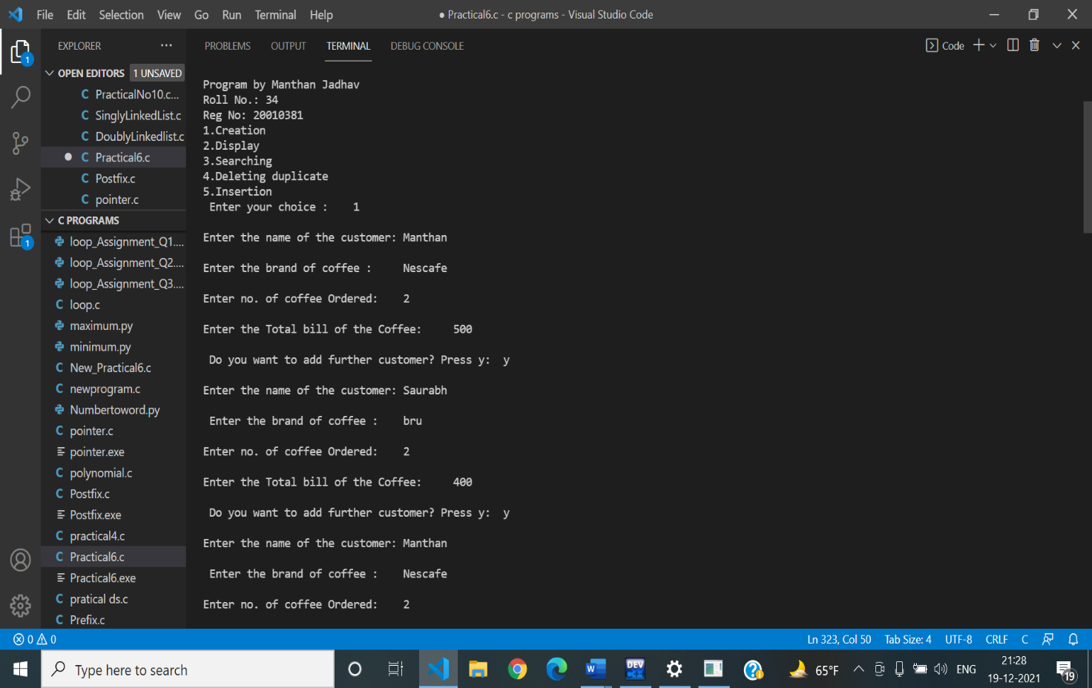

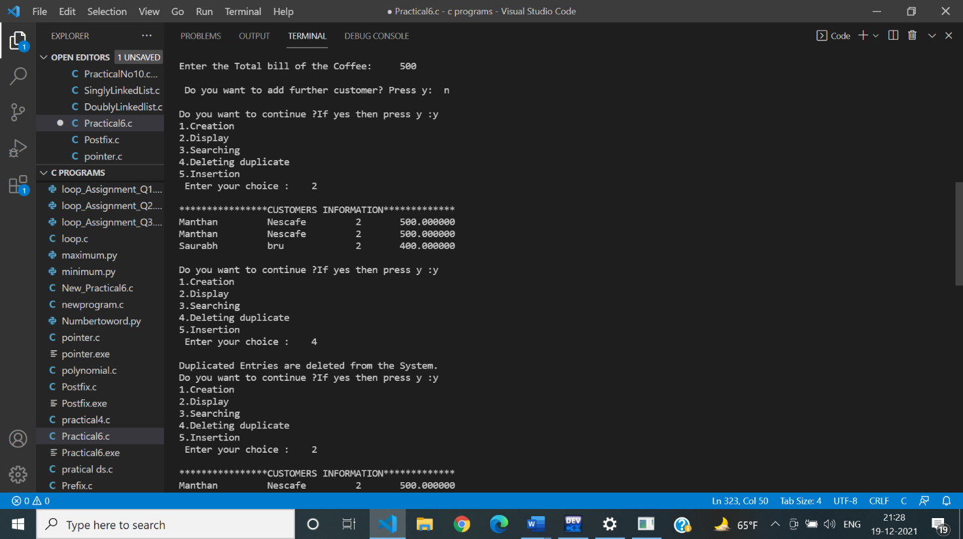

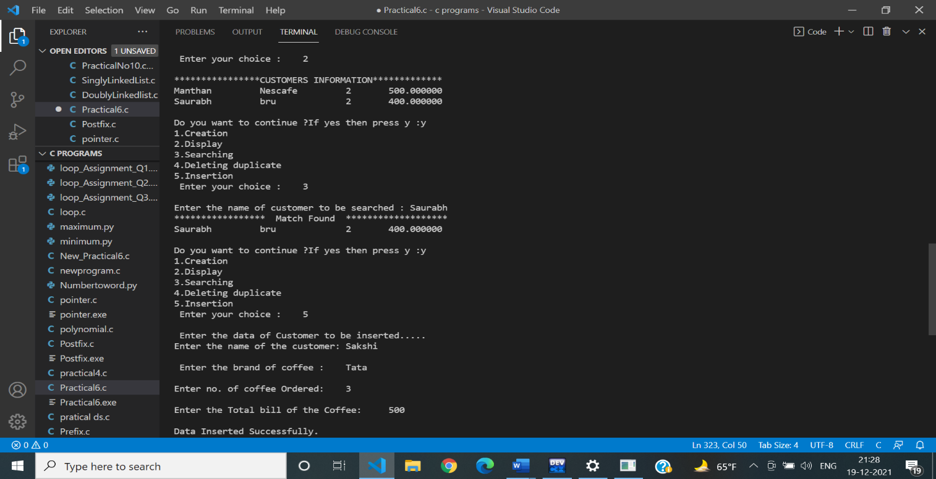

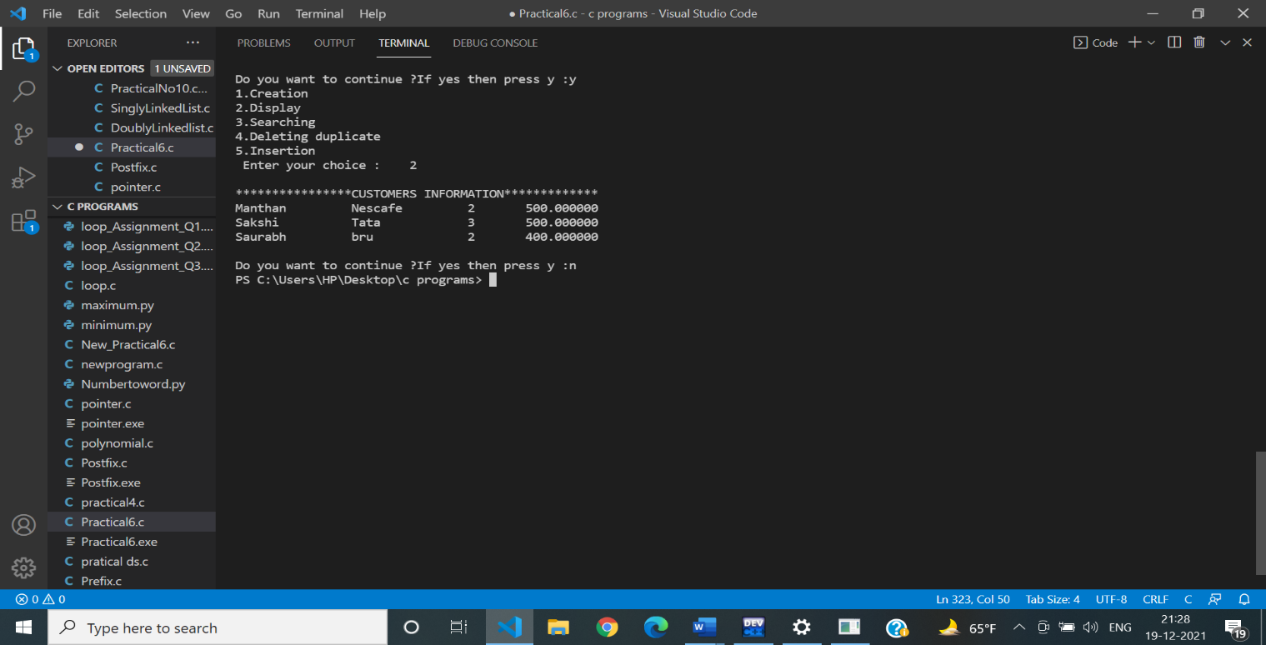

**Practical No 7**

**Aim:** Program for applications of stacks : infix to postfix.

**Program:**

|  |
| --- |
| /*Practical No. 7 infix to postfix*/  #include<stdio.h>  #include<conio.h>  #define MAX 15  char stk[MAX];  char postfix[MAX],infix[MAX];  int top=-1;  int isopr(char c)  {  return(c=='*'||c=='/'||c=='+'||c=='-'||c=='%');  }  int prio(char c)  {  if(c=='+'||c=='-')  return 1;  else if(c=='*'||c=='/'||c=='%')  return 2;  else  return 3;  }  int main()  {  printf("Program by Manthan Jadhav\n") ;  printf("Roll No.: 34\n");  printf("Reg No: 20010381\n");  int ch;  int i=0,j=0;  printf("\n Enter the Infix expression :\t");  scanf("%s",infix);  printf("\nInfix expression is :%s\n",infix);  for(i=0;infix[i]!='\0';i++)  {  if(infix[i]=='(')  {  top++;  stk[top]=infix[i];  }  else  {  if(infix[i]==')')  {  while(top>=0 && stk[top]!='(')  {  postfix[j]=stk[top];  printf("%c",postfix[j]);  j++;  top--;  }  top--;  }  else  {  if(!isopr(infix[i]))  {  postfix[j]=infix[i];  printf("%c",postfix[j]);  j++;  }  else  {  while(top>=0 && stk[top]!='(' && prio(stk[top])>=prio(infix[i]))  {  postfix[j]=stk[top];  printf("%c",postfix[j]);  top--;  j++;  }  top++;  stk[top]=infix[i];  }    }  }  }  while(top>=0)  {  if(stk[top]!='(')  {  postfix[j]=stk[top];  j++;  }  top--;  }  postfix[j]='\0';  printf("\nPostfix Expression is : %s",postfix);  getch();  }  /*  Program by Manthan Jadhav  Roll No.: 34  Reg No: 20010381  Enter the Infix expression : (a+(b*c))  Infix expression is :(a+(b*c))  abc*+  Postfix Expression is : abc*+  */ |

**OUTPUT:**

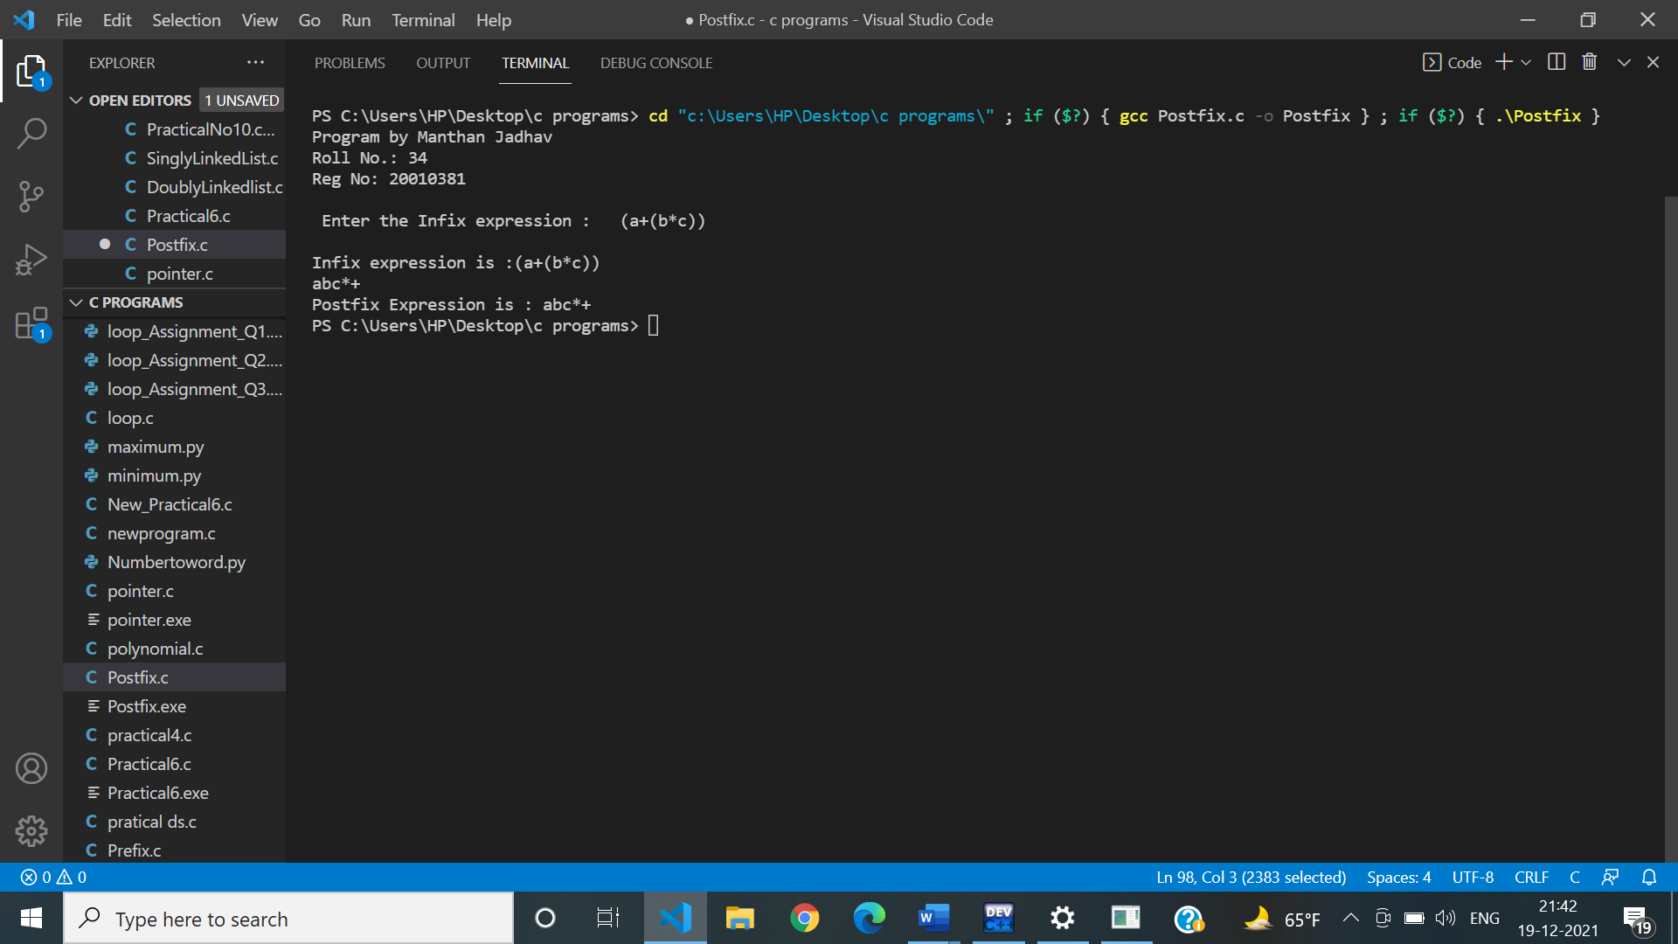

**Practical No 8**

**Aim:** Program based on application of queue.

**Program:**

|  |
| --- |
| //Practical No 8  #include<stdio.h>  #include<stdlib.h>  #define MAX 4  int main()  {  int que[MAX];  int val;  int rear=-1,i;  int front=-1;  char res;  int ch;  do  {    printf("\n1.Book the Appointments\n2.Delete the appointment who has done the checkup\n3.Display the appointment no yet to checked by the doctor");  printf("\nEnter your choice: ");  scanf("%d",&ch);  switch(ch)  {    case 1://insertion  if(rear==MAX-1 && rear>front)  {  printf("\nTodays Appointments are full.");  }  else  {  rear++;  front=0;  printf("\n\tEnter the appointment Number:");  scanf("%d",&val);  que[rear]=val;  }  break;  case 2://deletion  if(front==-1 && rear==-1 || front>rear)  {  printf("\n\t You can now book the appointments.");  }  else  {    val=que[front];  front++;  printf("\n %d Appointment number has done the Checkup.",val);    }  break;  case 3://display  printf("\n\t****Appointments****");  for(i=front;i<=rear;i++)  {  printf("\n\t%d",que[i]);    }  break;    default:  exit(0);  }  printf("\n\tWant to continue.if yes then press y:\t");  scanf("%s",&res);  } while(res=='y');  return 0;  }  /*  1.Book the Appointments  2.Delete the appointment who has done the checkup  3.Display the appointment no yet to checked by the doctor  Enter your choice: 1  Enter the appointment Number:1  Want to continue.if yes then press y: y  1.Book the Appointments  2.Delete the appointment who has done the checkup  3.Display the appointment no yet to checked by the doctor  Enter your choice: 1  Enter the appointment Number:2  Want to continue.if yes then press y: y  1.Book the Appointments  2.Delete the appointment who has done the checkup  3.Display the appointment no yet to checked by the doctor  Enter your choice: 1  Enter the appointment Number:3  Want to continue.if yes then press y: y  1.Book the Appointments  2.Delete the appointment who has done the checkup  3.Display the appointment no yet to checked by the doctor  Enter your choice: 1  Enter the appointment Number:4  Want to continue.if yes then press y: y  1.Book the Appointments  2.Delete the appointment who has done the checkup  3.Display the appointment no yet to checked by the doctor  Enter your choice: 1  Todays Appointments are full.  Want to continue.if yes then press y: y  1.Book the Appointments  2.Delete the appointment who has done the checkup  3.Display the appointment no yet to checked by the doctor  Enter your choice: 3  ****Appointments****  1  2  3  4  Want to continue.if yes then press y: y  1.Book the Appointments  2.Delete the appointment who has done the checkup  3.Display the appointment no yet to checked by the doctor  Enter your choice: 2  1 Appointment number has done the Checkup.  Want to continue.if yes then press y: y  1.Book the Appointments  2.Delete the appointment who has done the checkup  3.Display the appointment no yet to checked by the doctor  Enter your choice: 2  2 Appointment number has done the Checkup.  Want to continue.if yes then press y: y  1.Book the Appointments  2.Delete the appointment who has done the checkup  3.Display the appointment no yet to checked by the doctor  Enter your choice: 2  3 Appointment number has done the Checkup.  Want to continue.if yes then press y: y  1.Book the Appointments  2.Delete the appointment who has done the checkup  3.Display the appointment no yet to checked by the doctor  Enter your choice: 3  ****Appointments****  4  */ |

**OUTPUT:**

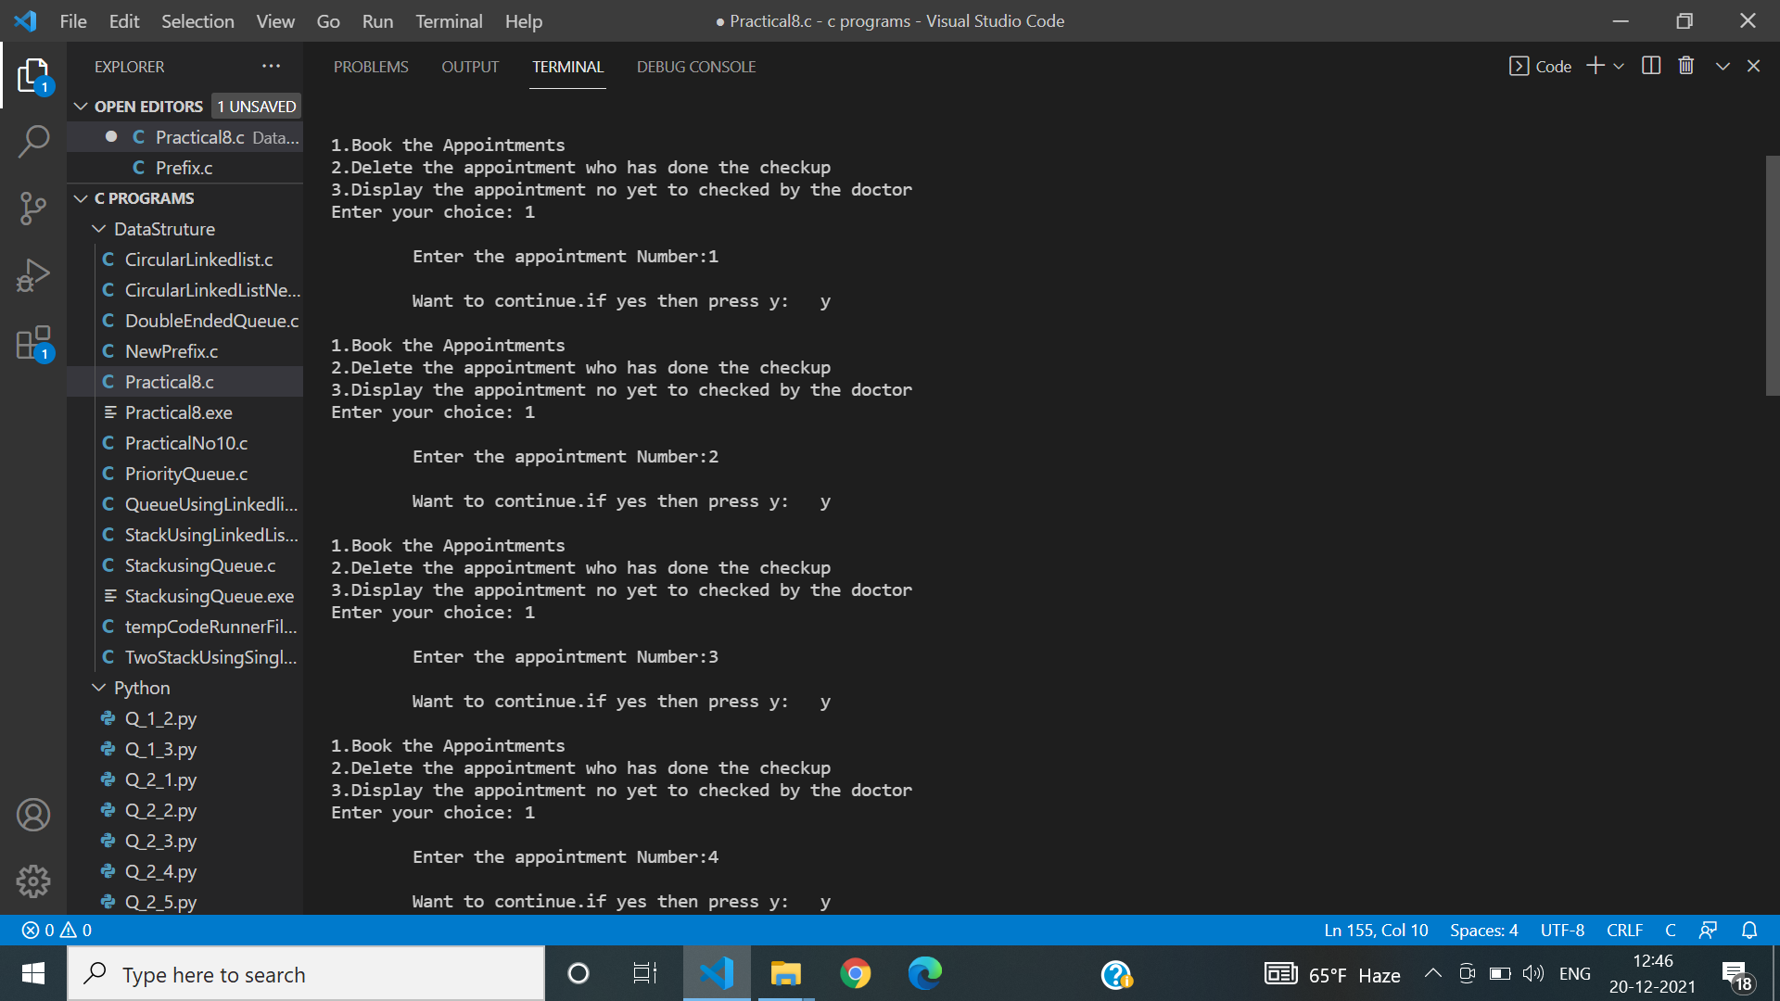

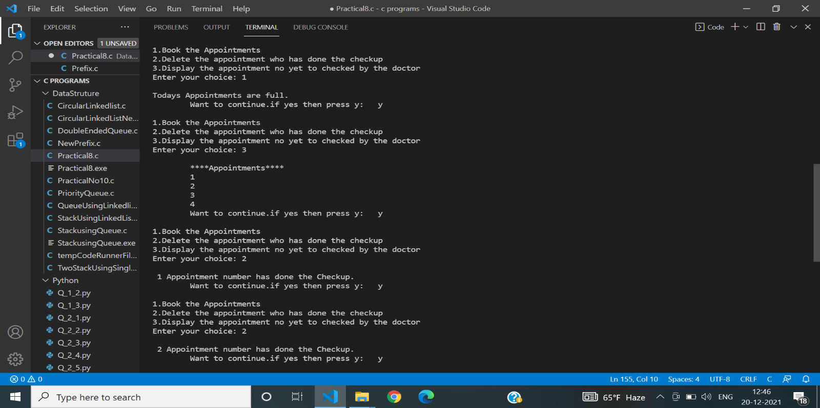

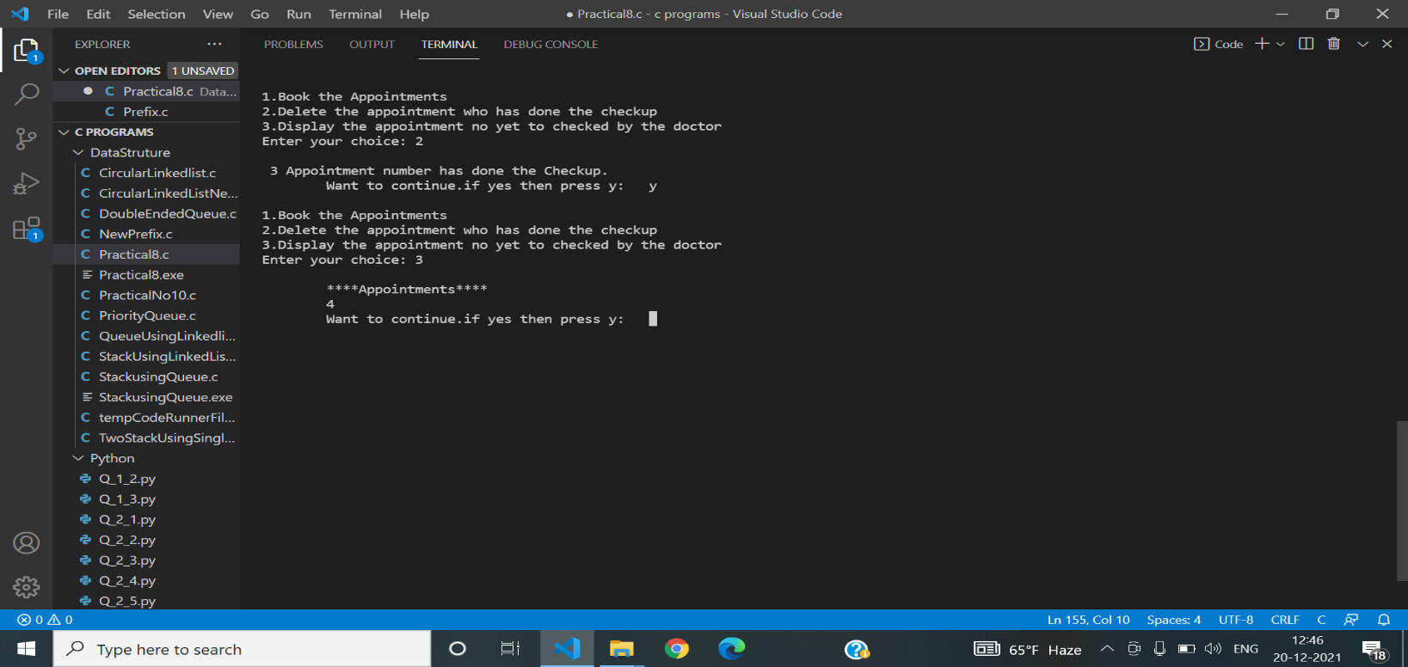

**Practical No 9**

**Aim:** Program for file handling.

**Problem Statement:**

Create a file of 10 records and perform following operations on it.

1.append new record

2.Search record

3.Store employees having salary > 20k in another file salary.txt

4.Display only those records who are staying at Mumbai.

**Program:**

|  |
| --- |
| /* Create a file of 10 records and perform following operations on it.  1.append new record  2.Search record  3.Store employees having salary > 20k in another file salary.txt  4.Display only those records who are staying at Mumbai.*/  #include<stdio.h>  #include<stdlib.h>  #include<conio.h>  #include<string.h>  #define MAX 15  FILE *fp;  struct Employee  {  int Id;  char name[MAX];  char city[MAX];  int salary;  }Em[MAX];  int main()  {  printf("Program by Manthan Jadhav\n") ;  printf("Roll No.: 34\n");  printf("Reg No: 20010381\n");  int i=0,n,ch,ID,found=0;  char res;  do  {  printf("1.Display\n2.Append\n3.Search\n4.Coping salary>20k into another file");  printf("\n5.Display People Staying in Mumbai");  printf("\n Enter your choice :\t");  scanf("%d",&ch);  switch(ch)  {  case 1://Reading  FILE *fp,*c;  fp=fopen("Employee.txt","r");  printf("ID\tNAME\tCITY\tSALARY\n");  while(fscanf(fp,"%d\t%s\t%s\t%d",&Em[i].Id,&Em[i].name,&Em[i].city,&Em[i].salary)!=EOF)  {  printf("\n%d\t%s\t%s\t%d\n",Em[i].Id,Em[i].name,Em[i].city,Em[i].salary);  i++;  }  fclose(fp);  break;  case 2://Append  printf("\n\t\tEnter the number of Employees :\t");  scanf("%d",&n);  fp = fopen("Employee.txt","a");  for(i=0;i<n;i++)  {  printf("\nEnter Id: ");  scanf("%d",&Em[i].Id);  printf("Enter name: ");  scanf("%s",&Em[i].name);  printf("Enter city: ");  scanf("%s",&Em[i].city);  printf("Enter salary: ");  scanf("%d",&Em[i].salary);  fprintf(fp,"\n%d\t%s\t%s\t%d",Em[i].Id,Em[i].name,Em[i].city,Em[i].salary);  }  fclose(fp);  break;  case 3://Search Record  found=0;  printf("\n\tEnter the ID to be searched :\t");  scanf("%d",&ID);  fp=fopen("Employee.txt","r");  while(fscanf(fp,"%d\t%s\t%s\t%d",&Em[i].Id,&Em[i].name,&Em[i].city,&Em[i].salary)!=EOF)  {  if(Em[i].Id==ID)  {  found=1;  printf("ID\tNAME\tCITY\tSALARY\n");  printf("\n%d\t%s\t%s\t%d\n",Em[i].Id,Em[i].name,Em[i].city,Em[i].salary);  }  i++;  }  if(found==0)  {  printf("\n\t\tRecord Not Found.");  }  fclose(fp);  break;  case 4://Copying people having Salary>20000 into salary.txt  found=0;  fp=fopen("Employee.txt","r");  c=fopen("Salary.txt","w");  fprintf(c,"ID\tNAME\tCITY\tSALARY\n");  while(fscanf(fp,"%d\t%s\t%s\t%d",&Em[i].Id,&Em[i].name,&Em[i].city,&Em[i].salary)!=EOF)//End of file  {  if(Em[i].salary>20000)  {  found=1;  fprintf(c,"\n%d\t%s\t%s\t%d\n",Em[i].Id,Em[i].name,Em[i].city,Em[i].salary);  }  i++;  }  if(found>0)  {  printf("Data copied Successfully.\n");  }  if(found==0)  {  printf("\n\t\tNO one has salary more than 20k.");  }  fclose(fp);  fclose(c);  break;  case 5://Display people staying in mumbai  found=0;  fp=fopen("Employee.txt","r");  printf("ID\tNAME\tCITY\tSALARY\n");  while(fscanf(fp,"%d\t%s\t%s\t%d",&Em[i].Id,&Em[i].name,&Em[i].city,&Em[i].salary)!=EOF)//End of file  {  if(strcmp(Em[i].city,"Mumbai")==0)  {  found=1;  printf("\n%d\t%s\t%s\t%d\n",Em[i].Id,Em[i].name,Em[i].city,Em[i].salary);  }  i++;  }  if(found==0)  {  printf("\n\t\tNO one staying in Mumbai.");  }  fclose(fp);  break;  default:  exit(0);  }  printf("\nDo you want to continue ?If yes then press y :");  scanf("%s",&res);  }while(res=='y');  }  /*Program by Manthan Jadhav  Roll No.: 34  Reg No: 20010381  1.Display  2.Append  3.Search  4.Coping salary>20k into another file  5.Display People Staying in Mumbai  Enter your choice : 1  ID NAME CITY SALARY  101 Manthan Nagpur 56000  102 Lalit Mumbai 19000  103 Saurabh Delhi 25000  104 Arnav Nagpur 30000  105 Aditya Kolkata 15000  106 Akshay Mumbai 45000  107 Tejas Mumbai 35000  108 Sakshi Nagpur 20000  109 Gunjan Delhi 17000  110 Sushant Akola 18000  Do you want to continue ?If yes then press y :y  1.Display  2.Append  3.Search  4.Coping salary>20k into another file  5.Display People Staying in Mumbai  Enter your choice : 2  Enter the number of Employees : 2  Enter Id: 111  Enter name: Vedant  Enter city: Nagpur  Enter salary: 45000  Enter Id: 112  Enter name: Sachin  Enter city: Pune  Enter salary: 19000  Do you want to continue ?If yes then press y :y  1.Display  2.Append  3.Search  4.Coping salary>20k into another file  5.Display People Staying in Mumbai  Enter your choice : 3  Enter the ID to be searched : 106  ID NAME CITY SALARY  106 Akshay Mumbai 45000  Do you want to continue ?If yes then press y :y  1.Display  2.Append  3.Search  4.Coping salary>20k into another file  5.Display People Staying in Mumbai  Enter your choice : 4  Data copied Successfully.  Do you want to continue ?If yes then press y :y  1.Display  2.Append  3.Search  4.Coping salary>20k into another file  5.Display People Staying in Mumbai  Enter your choice : 5  ID NAME CITY SALARY  102 Lalit Mumbai 19000  106 Akshay Mumbai 45000  107 Tejas Mumbai 35000  Do you want to continue ?If yes then press y :n*/ |

**OUTPUT:**

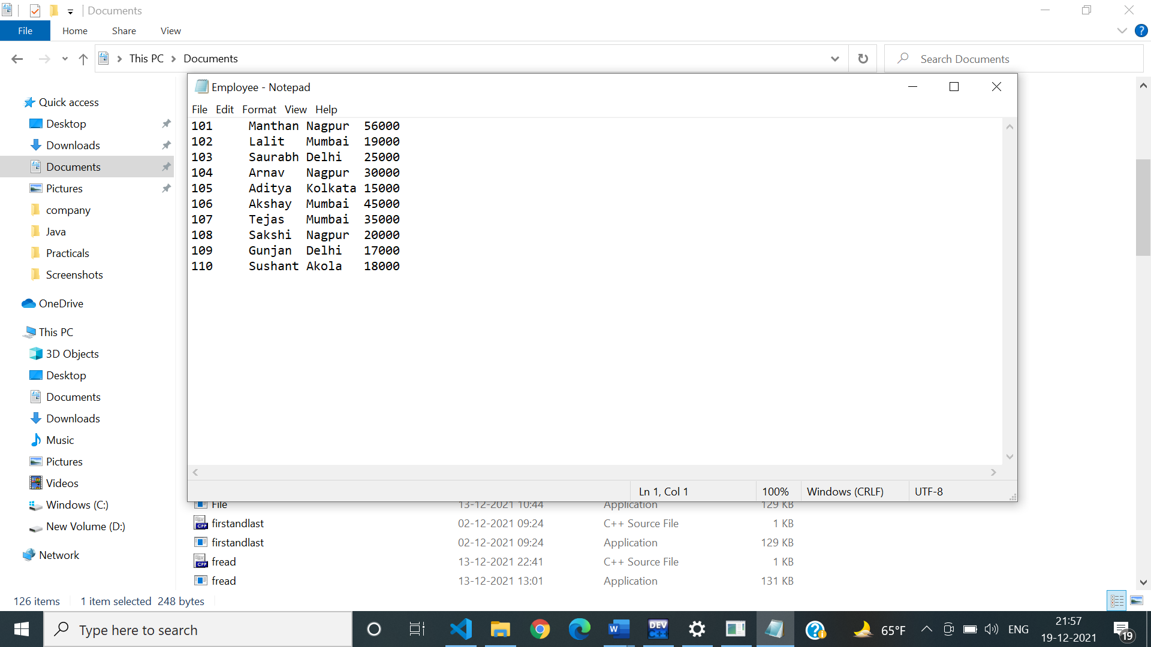

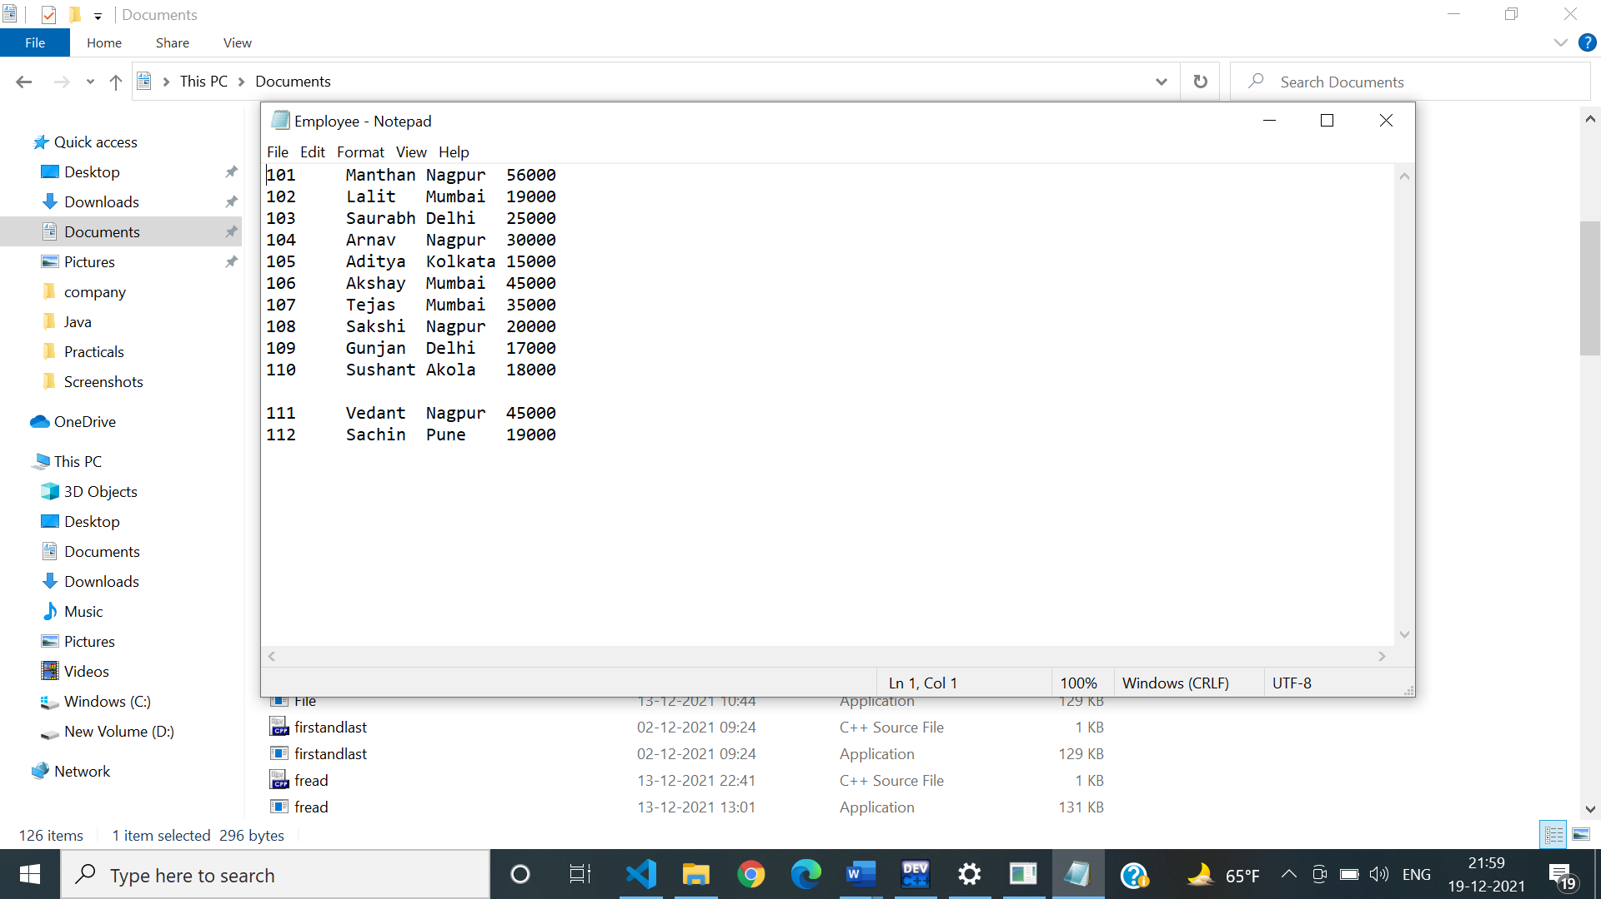

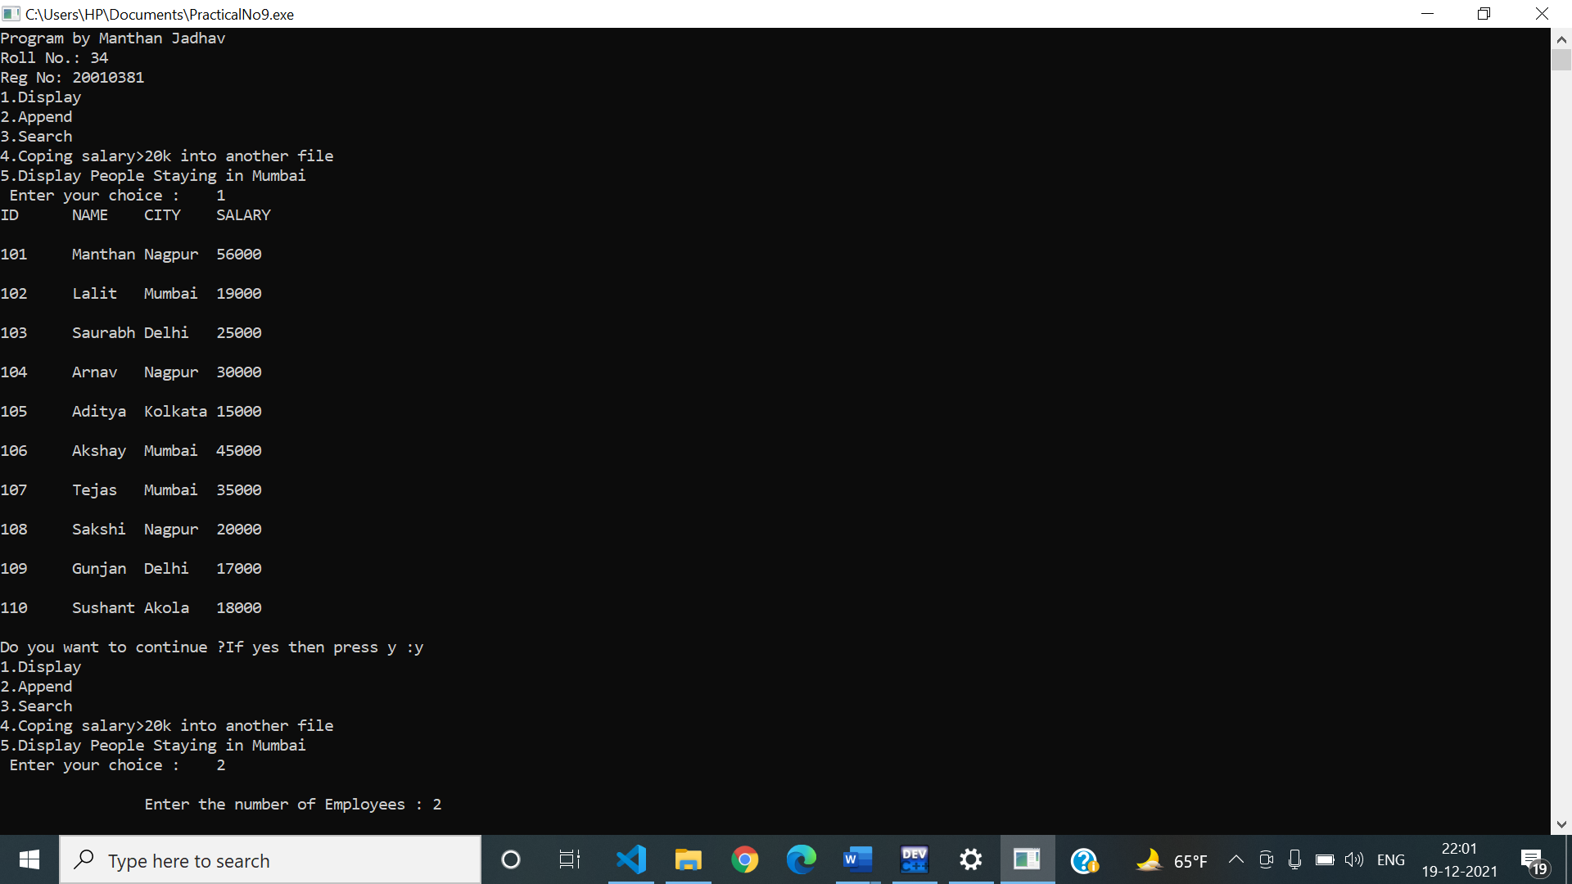

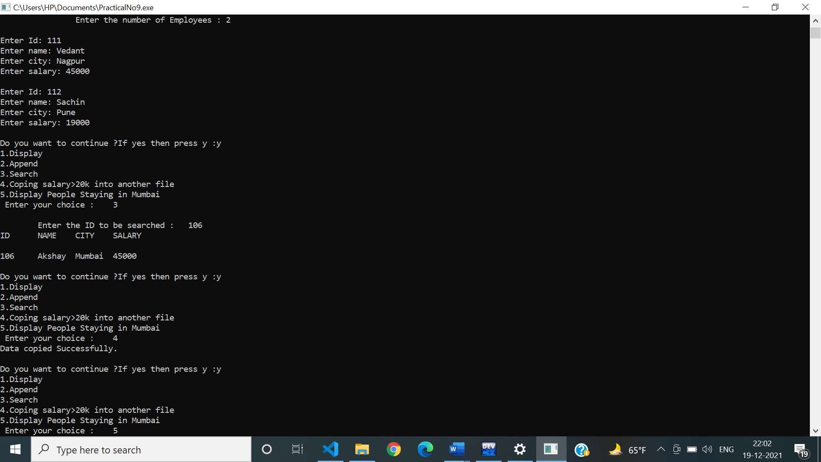

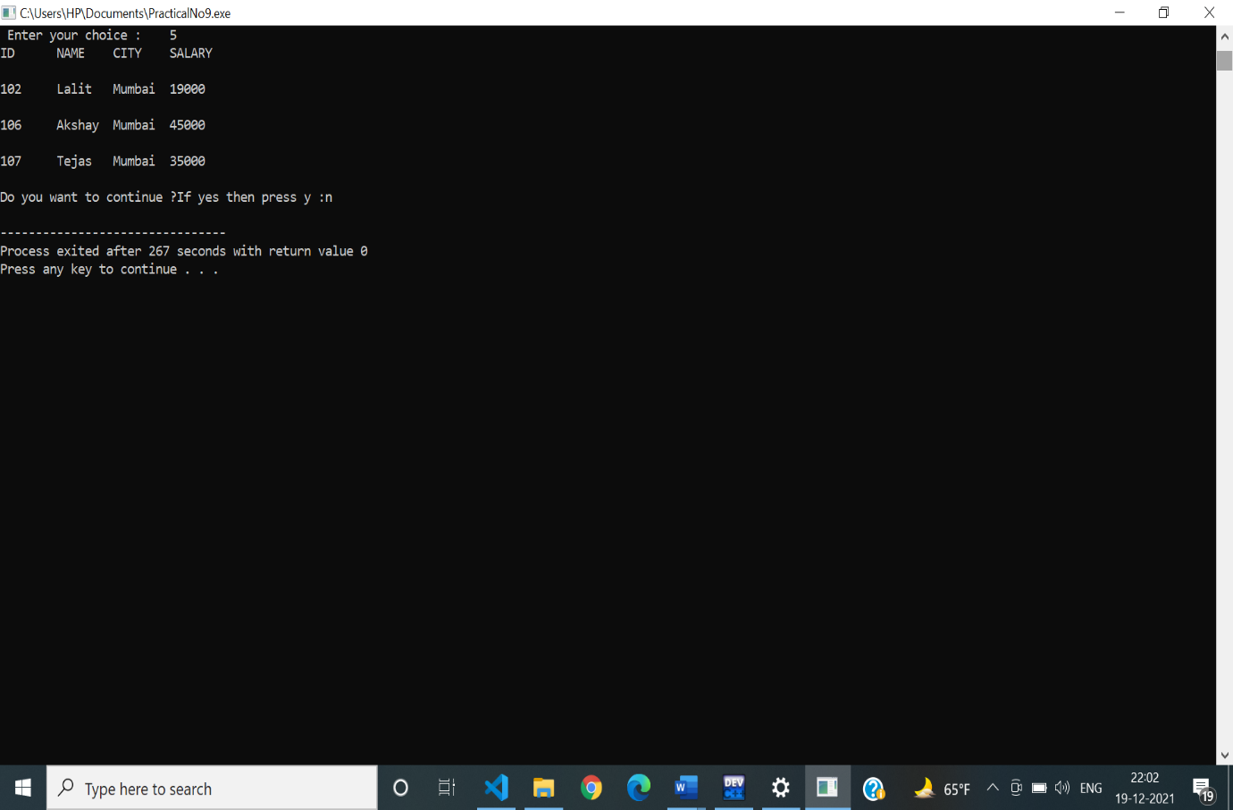

**Practical No 10**

**Aim:** Implementation of following applications using arrays , structures ,files ,linked list, stacks and queue.

1.Shopping mall application

2.Insurance claim at automobile

3.Cinema theatre

4.Petrol pump

5.Online shopping.

**Program:**

|  |
| --- |
| /*Implementation of following applicatons using arrays,structures,files,linked list,stacks and queue.  1.Shopping mall application  2.Insurance claim at automobile  3.Cinema theatre  4.Petrol pump  5.Online shoping*/  #include<stdio.h>  #include<string.h>  #include<stdlib.h>  #include<conio.h>  #define MAX 20  typedef struct Petrol_Pump  {  int cust_No;  char Fuel[MAX];  int N;  float Bill;  char P_Type[MAX];  struct Petrol_Pump *next;  }*Pp;  FILE *fp;  Pp getnode()  {  Pp new1;  new1=malloc(sizeof(struct Petrol_Pump));  new1->next=NULL;  }  Pp head=NULL;  int main()  {  int ch;  char res;  Pp temp,new1;  do  {  printf("\n---------------------------------------------------------------------------------------------------------------------------\n");  printf("1.Creation\n2.Display\n3.Total Collection from sell of petrol\n4.Total Collection from the sell of Diesel");  printf("\n5.Total sell of petrol in litre\n6.Total sell of diesel in litre");  printf("\n7.Save the Record in the file.");  printf("\n---------------------------------------------------------------------------------------------------------------------------\n");  printf("\n Enter your choice :\t");  scanf("%d",&ch);  switch(ch)  {  case 1://Creation  do  {  if(head==NULL)  {  head=getnode();  printf("\nEnter the customer number:\t");  scanf("%d",&head->cust_No);  printf("\nEnter the type of fuel :\t");  scanf("%s",&head->Fuel);  printf("\nEnter the fuel in litre:\t");  scanf("%d",&head->N);  if(strcmp(head->Fuel,"petrol")==0)  {  head->Bill=head->N*110.82;  }  else  {  head->Bill=head->N*105.45;  }  printf("\nEnter the Payment method Cash/Card/online :\t");  scanf("%s",&head->P_Type);  temp=head;  }  else  {  new1=getnode();  printf("\nEnter the customer number:\t");  scanf("%d",&new1->cust_No);  printf("\nEnter the type of fuel :\t");  scanf("%s",&new1->Fuel);  printf("\nEnter the fuel in litre:\t");  scanf("%d",&new1->N);  if(strcmp(new1->Fuel,"petrol")==0)  {  new1->Bill=new1->N*110.82;  }  else  {  new1->Bill=new1->N*105.45;  }  printf("\nEnter the Payment method Cash/Card/online :\t");  scanf("%s",&new1->P_Type);  temp->next=new1;  temp=new1;  }  printf("\nDo you want to add further customer? Press y:\t");  scanf("%s",&res);  }while(res=='y');  break;  case 2://display  temp=head;  printf("\n********CUSTOMERS INFORMATION**********");  printf("\n---------------------------------------\n");  printf("Cus_No\tFuel\tLitre\tBill\tPayment");  printf("\n---------------------------------------\n");  while(temp!=NULL)  {  printf("%d\t%s\t%d L\t%.2f\t%s\n",temp->cust_No,temp->Fuel,temp->N,temp->Bill,temp->P_Type);  temp=temp->next;  }  break;  case 3:  temp=head;  float sum1=0;  while(temp!=NULL)  {  if(strcmp(temp->Fuel,"petrol")==0)  {  sum1 =sum1+temp->Bill;  }  temp=temp->next;  }  printf("\nTotal collection from sell of petrol is : %.3fRs\n",sum1);  break;  case 4:  temp=head;  float sum2=0;  while(temp!=NULL)  {  if(strcmp(temp->Fuel,"diesel")==0)  {  sum2 =sum2+temp->Bill;  }  temp=temp->next;  }  printf("\nTotal collection from sell of diesel is : %.3fRs\n",sum2);  break;  case 5://Total sell of petrol  temp=head;  int sum=0;  while(temp!=NULL)  {  if(strcmp(temp->Fuel,"petrol")==0)  {  sum=sum+temp->N;  }  temp=temp->next;  }  printf("\nTotal sell of petrol is %d Liters",sum);  break;  case 6://Total sell of diesel  temp=head;  int sum3=0;  while(temp!=NULL)  {  if(strcmp(temp->Fuel,"diesel")==0)  {  sum3=sum3+temp->N;  }  temp=temp->next;  }  printf("\nTotal sell of petrol is %d Liters",sum3);  break;  case 7:  temp=head;  FILE *fp;  fp=fopen("Totalrecord.txt","a");  while(temp!=NULL)  {  fprintf(fp,"%d\t%s\t%d L\t%.2f\t%s\n",temp->cust_No,temp->Fuel,temp->N,temp->Bill,temp->P_Type);  temp=temp->next;  }  fclose(fp);  printf("Data Saved Successfully in the file...");  break;  default:  exit(0);  }  printf("\nDo you want to continue ?If yes then press y :");  scanf("%s",&res);    }while(res=='y');  }  /*---------------------------------------------------------------------------------------------------------------------------  1.Creation  2.Display  3.Total Collection from sell of petrol  4.Total Collection from the sell of Diesel  5.Total sell of petrol in litre  6.Total sell of diesel in litre  7.Save the Record in the file.  ---------------------------------------------------------------------------------------------------------------------------  Enter your choice : 1  Enter the customer number: 1  Enter the type of fuel : petrol  Enter the fuel in litre: 5  Enter the Payment method Cash/Card/online : Online  Do you want to add further customer? Press y: y  Enter the customer number: 2  Enter the type of fuel : diesel  Enter the fuel in litre: 8  Enter the Payment method Cash/Card/online : Cash  Do you want to add further customer? Press y: y  Enter the customer number: 3  Enter the type of fuel : diesel  Enter the fuel in litre: 9  Enter the Payment method Cash/Card/online : Card  Do you want to add further customer? Press y: y  Enter the customer number: 4  Enter the type of fuel : petrol  Enter the fuel in litre: 9  Enter the Payment method Cash/Card/online : Cash  Do you want to add further customer? Press y: n  Do you want to continue ?If yes then press y :y  ---------------------------------------------------------------------------------------------------------------------------  1.Creation  2.Display  3.Total Collection from sell of petrol  4.Total Collection from the sell of Diesel  5.Total sell of petrol in litre  6.Total sell of diesel in litre  7.Save the Record in the file.  ---------------------------------------------------------------------------------------------------------------------------  Enter your choice : 2  ********CUSTOMERS INFORMATION**********  ---------------------------------------  Cus_No Fuel Litre Bill Payment  ---------------------------------------  1 petrol 5 L 554.10 Online  2 diesel 8 L 843.60 Cash  3 diesel 9 L 949.05 Card  4 petrol 9 L 997.38 Cash  Do you want to continue ?If yes then press y :y  ---------------------------------------------------------------------------------------------------------------------------  1.Creation  2.Display  3.Total Collection from sell of petrol  4.Total Collection from the sell of Diesel  5.Total sell of petrol in litre  6.Total sell of diesel in litre  7.Save the Record in the file.  ---------------------------------------------------------------------------------------------------------------------------  Enter your choice : 3  Total collection from sell of petrol is : 1551.480Rs  Do you want to continue ?If yes then press y :y  ---------------------------------------------------------------------------------------------------------------------------  1.Creation  2.Display  3.Total Collection from sell of petrol  4.Total Collection from the sell of Diesel  5.Total sell of petrol in litre  6.Total sell of diesel in litre  7.Save the Record in the file.  ---------------------------------------------------------------------------------------------------------------------------  Enter your choice : 4  Total collection from sell of diesel is : 1792.650Rs  Do you want to continue ?If yes then press y :y  ---------------------------------------------------------------------------------------------------------------------------  1.Creation  2.Display  3.Total Collection from sell of petrol  4.Total Collection from the sell of Diesel  5.Total sell of petrol in litre  6.Total sell of diesel in litre  7.Save the Record in the file.  ---------------------------------------------------------------------------------------------------------------------------  Enter your choice : 5  Total sell of petrol is 14 Liters  Do you want to continue ?If yes then press y :y  ---------------------------------------------------------------------------------------------------------------------------  1.Creation  2.Display  3.Total Collection from sell of petrol  4.Total Collection from the sell of Diesel  5.Total sell of petrol in litre  6.Total sell of diesel in litre  7.Save the Record in the file.  ---------------------------------------------------------------------------------------------------------------------------  Enter your choice : 6  Total sell of petrol is 17 Liters  Do you want to continue ?If yes then press y :y  ---------------------------------------------------------------------------------------------------------------------------  1.Creation  2.Display  3.Total Collection from sell of petrol  4.Total Collection from the sell of Diesel  5.Total sell of petrol in litre  6.Total sell of diesel in litre  7.Save the Record in the file.  ---------------------------------------------------------------------------------------------------------------------------  Enter your choice : 7  Data Saved Successfully in the file...  Do you want to continue ?If yes then press y :n  PS C:\Users\HP\Desktop\c programs\DataStruture>  */ |

**OUTPUT:**

